**Lab 6.4 Excel: Descriptive Analytics**

Student Name

Date

**Creating a Dashboard Using Pivot Tables and Slicers**

Submission 1

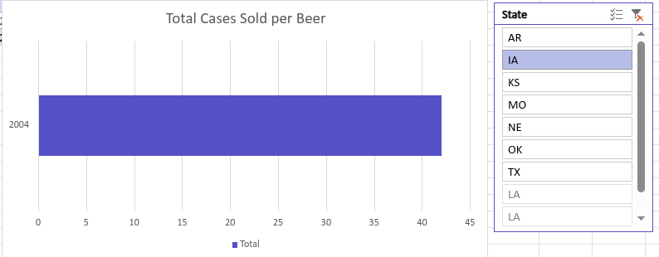

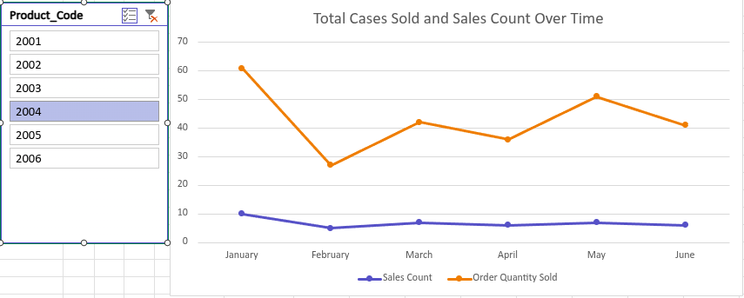

Submission 2

